SARDAR VALLABHBHAI NATIONAL INSTITUTE OF TECHNOLOGY, SURAT
DEPARTMENT OF CIVIL ENGINEERING
GEOTECHNICAL ENGINEERING SECTION
GEOTECHNICAL ENGINEERING LABORATORY
Geotechnical engineering laboratory was established in the year 1961. The laboratory is located at CB15 in the Department of Civil Engineering (Old AMD Block). The facilities available in the laboratory are intended to train the students in the field of testing of soils to determine their physical, index and engineering properties. The Geotechnical Laboratory is well-equipped with testing equipment for evaluating all engineering properties of soils and rocks, including index properties, compaction characteristics of soils, hydraulic characteristics, compressibility, rate of consolidation, triaxial strength and shear strength. The equipment ranges from the most fundamental to the most sophisticated and is used in both UG and PG teaching and research. The research scholars also utilize it for the research and development activities. The existing equipment are also used for generating revenue through consultancy work. List of equipment available in the laboratory is given below:

S. No. | Equipment Name
 | Casagrande Apparatus
 | Hot air oven
 | Permeability Apparatus
 | Field Density kit
 | Specific Gravity kit
 | Universal Automatic Compactor
 | Proctor Compaction test setup
 | IS Sieves and Hydrometer
 | Sample Extractor
 | Cone penetrometer Automatic (Universal penetrometer)
 | Triaxial Test Apparatus with Electronics Data Acquisition system and geotechnical analysis software
 | Consolidation Apparatus
 | Vain Shear test apparatus
 | Direct Shear Apparatus Electronic
 | Laboratory CBR testing machine
 | Swell Pressure test apparatus
 | Relative Density Apparatus
 | Strains Measurement Digital Display unit
 | Load Frame
 | Data logger with computer software
 | Large Direct Shear Test Machine

Information Regarding Few Important Set Ups in the GE Laboratory

- Cone penetrometer Automatic (Universal penetrometer) –
BS: 1377,IS:2720 (Part-V) IS:11196-1985 Inclusive of penetration test cone 35mm long penetration test cup.55mm dia x 40, Supplier:- M/s Aimil Ltd., New Delhi
USE: Evaluates soil compaction, soil consistency, and bearing capacity of foundations and pavement subgrades. It provides an accurate and continuous profile of soil stratification.
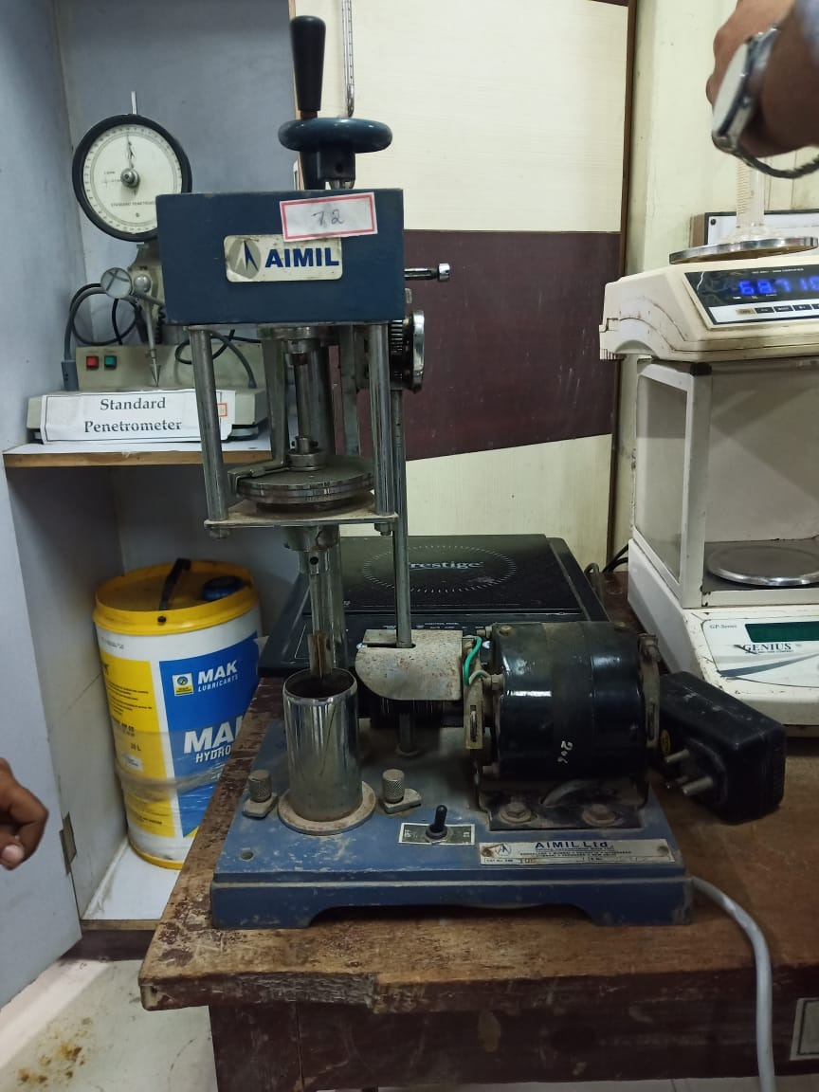
- Triaxial Test Apparatus with Electronics Data Acquisition system and geotechnical analysis software –
Pressure Cell (for 38 and 54 mm dia samples), Pressure Transducer of capacity 200 kPa (2 nos) and 500 kPa (1 no) with resolution of 0.5 kPa or less , 8 channel Digital unit including its calibration with 4 nos LVDT and 1 no Load Cell, Supplier:- M/s. Electropulse Uttarakhand
USE: To determine shear strength and mechanical characteristics of the soil
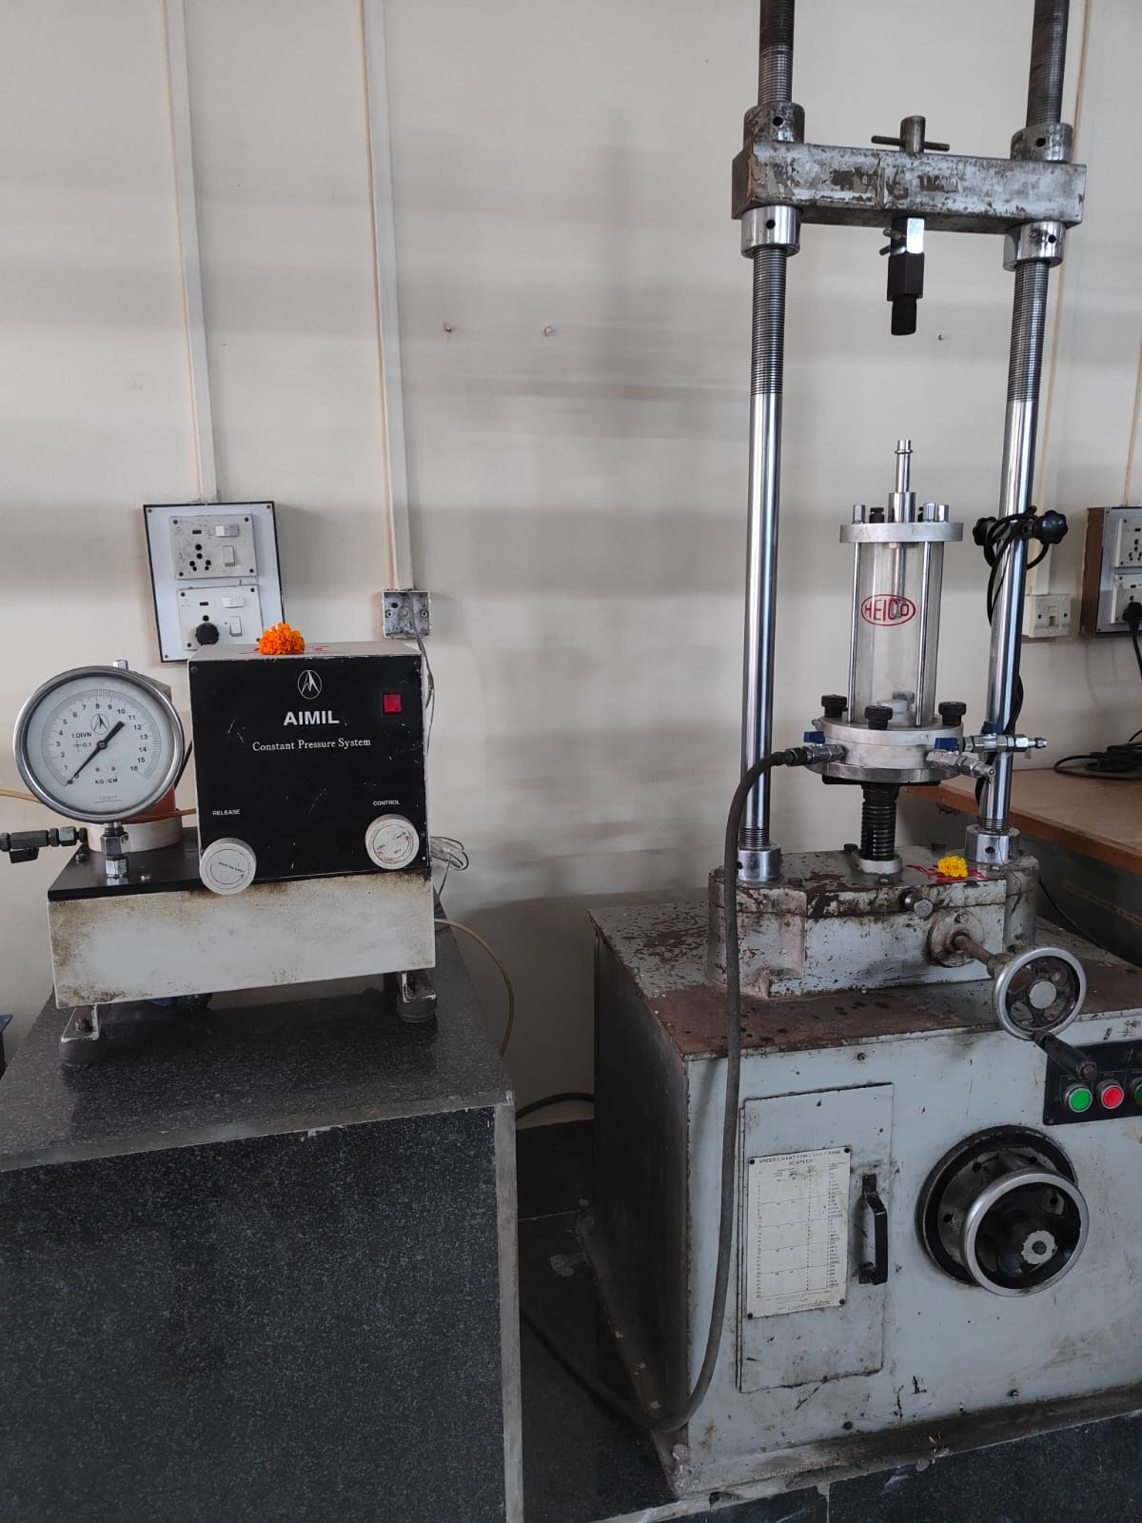
- Consolidation Apparatus -
3 Gang Electronic, Supplier:- M/s Aimil Ltd., New Delhi
USE: Determine the rate and magnitude of soil consolidation when the soil is restrained laterally and loaded axially.
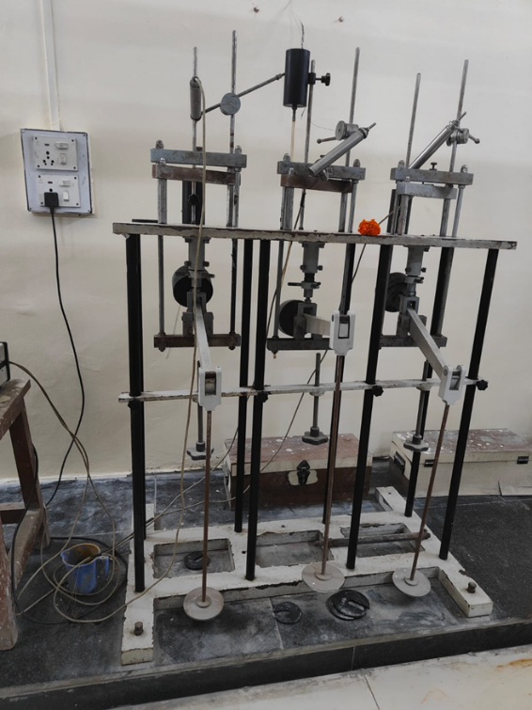
- Direct Shear Apparatus Electronic -
Capacity 2.5kN, Supplier:- M/s Aimil Ltd., New Delhi
USE: To determine shear strength and mechanical characteristics of the soil
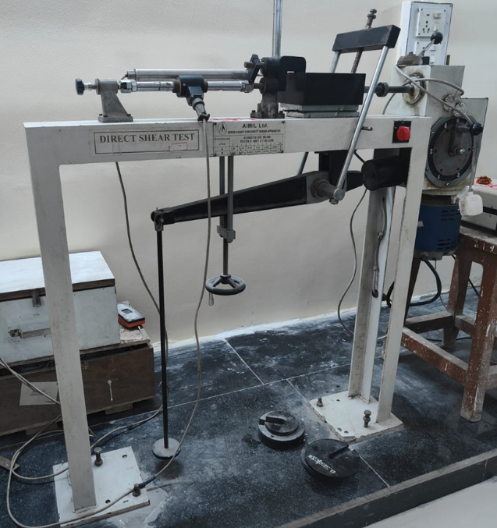
- Relative Density Apparatus
Supplier:- M/s. Hydraulic & Engineering Instruments New Delhi
USE: Determines the relative density of granular soils that do not respond well to Proctor moisture-density tests. Maximum density is determined by placing soil in special molds and densifying using a vibrating table and surcharge.
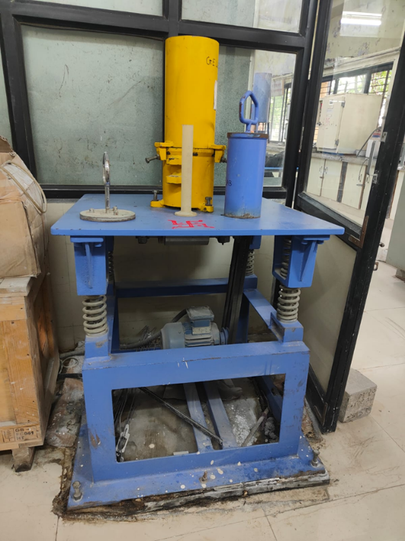
- Load Frame
Motorized, 200 KN Capacity Supplier:- M/s. Tirth Enterprise
USE: For applying vertical force in triaxial and many other laboratory tests where vertical load has to be applied
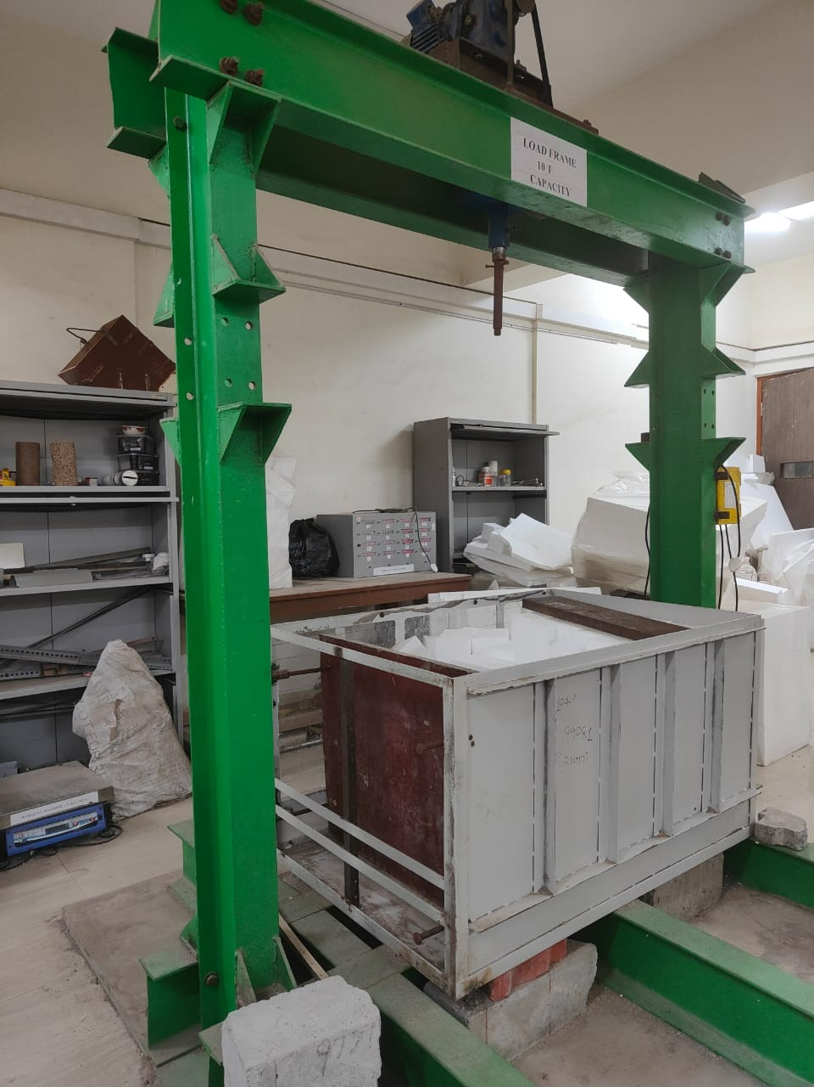
- Data logger with computer software
Digital 8 Channel, Supplier:- Patel Calibration Service, Ahmedabad
USE: Used to store/record data over time or location
- Large Direct Shear Test Machine
Capacity 50 kN, 3 LVDT's for Displacement Measurement, Operation: Motorised, Rates of Strain: 0.0014 to 10.16 mm/min, Shear load capacity: 50 kN, Load cell for horizontal and vertical loading, Supplier :-HEICO
USE: To determine Shear Strength parameter i.e. angle of shearing resistance and cohesion of soil & aggregate as per IS: 2720 (Part 39, Section -1) and IS:11593.

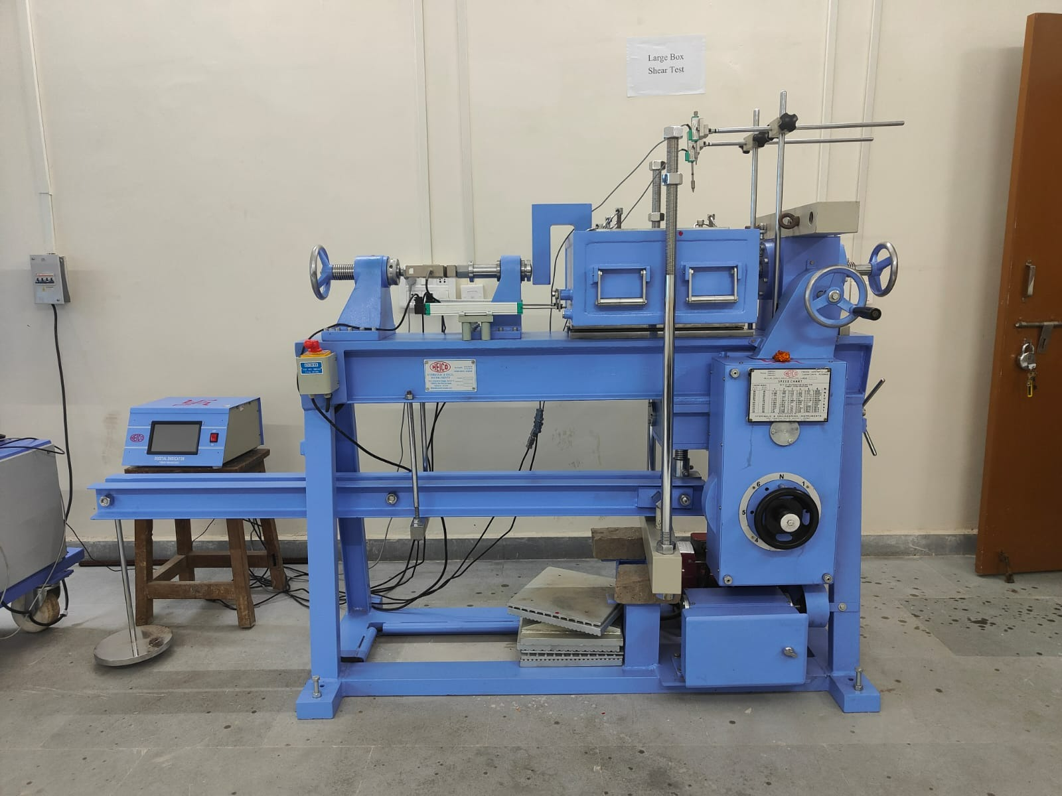

LIST OF EXPERIMENTS
Geotechnical Engineering (CE207) (B. Tech-II (Civil), Semester III)
Sr. No. | Title of Experiment
1 | Determination of moisture content density of soil
2 | Grain size analysis
3 | Consistency limits of soil.
4 | Compaction test on soil
5 | Determination of coefficient of permeability of soil.
6 | Estimation of shear resistance of noncohesive by direct shear test.
7 | Estimation of shear resistance of cohesive by vane and UCc tests.
8 | Computation of consolidation parameters
9 | Demonstration of triaxial shear test and computation of C & φ
10 | Demonstration of Exploration program and study different field tests.

LIST OF EXPERIMENTS
Geotechnical Engineering Laboratory-1 (CEGT104) (M. Tech-I (Civil), Semester I)
Sr. No. | Title of Experiment
1 | Compaction tests - standard and modified Proctor tests
2 | Permeability tests – constant head and falling head methods
3 | Unsoaked and soaked CBR tests
4 | Unconfined compression test
5 | Vane shear and Direct shear test
6 | Consolidation test
7 | Triaxial compression test (UU, CU & CD)
8 | Swell pressure test
9 | Relative density test
10 | Cyclic triaxial test
11 | Field geotechnical investigations and field tests: Drilling of bore holes; undisturbed sampling and Standard Penetration Test
12 | Dynamic Cone Penetration Test (large and small size)
13 | Structural evaluation of road pavement using Falling Weight Deflectometer

